October 8th Newsletter
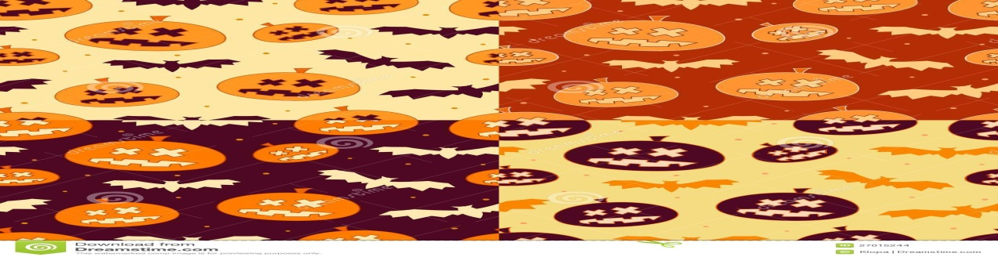
Dear Year 3 Parents,
I hope you had a lovely, long weekend; I would like to remind you that the first after school activity will start on Tuesday, 10th of October, 2017. It will consist of seven classes and will take place every Tuesday from 2:15 pm till 2:50 pm.
Below is this week’s plan, if you have any questions, please do not hesitate to contact me over weebly.
Regards, Mrs. Sherine
This week:
English:
We will continue looking at Unit one in the Pupil book where Students will write a story consisting of five paragraphs.
Grammar: Unit 5 – Speech marks
Spelling: prefix (re)
Replay, return, review, repeat, refresh, recycle, remember, rewrite, refill, rearrange
Social:
We will continue looking at Unit one “Life in a village” students will learn about directions and compasses.
Maths:
2D and 3D Shapes (sides, vertices and angles)
Science:
We will continue looking at Chapter one: living things. This week we will get to know different types of living things.

